**Logging in to your Laptop at Home**

**Setup**

Begin by assembling your equipment in your work area. You should have been given all necessary parts. Find a location in good range to your wifi router.

Example of laptops pictured below. You can also plug in your Jabber headset and webcam if applicable to your role, into available USB ports.

Example of a Lenovo dock with cables plugged in from left to right…

Power, Video, Mouse, Keyboard, Ethernet (not needed with wifi).

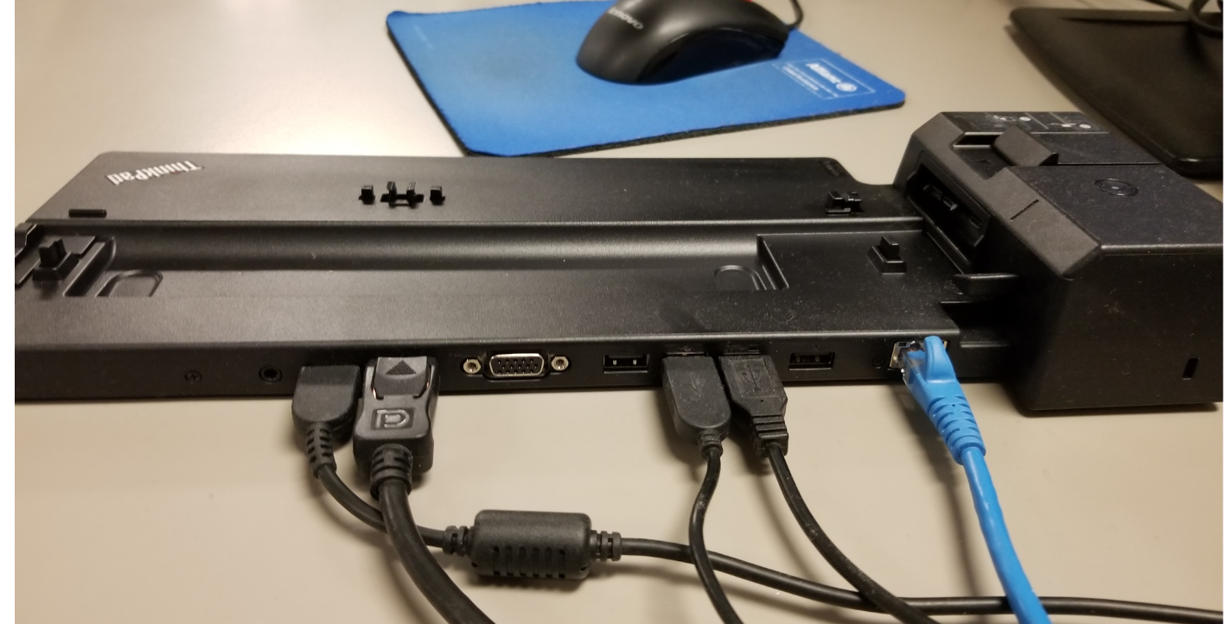

Example of an HP dock with cables plugged in from left to right…

Video, Ethernet (not needed with wifi, mouse, keyboard, Power

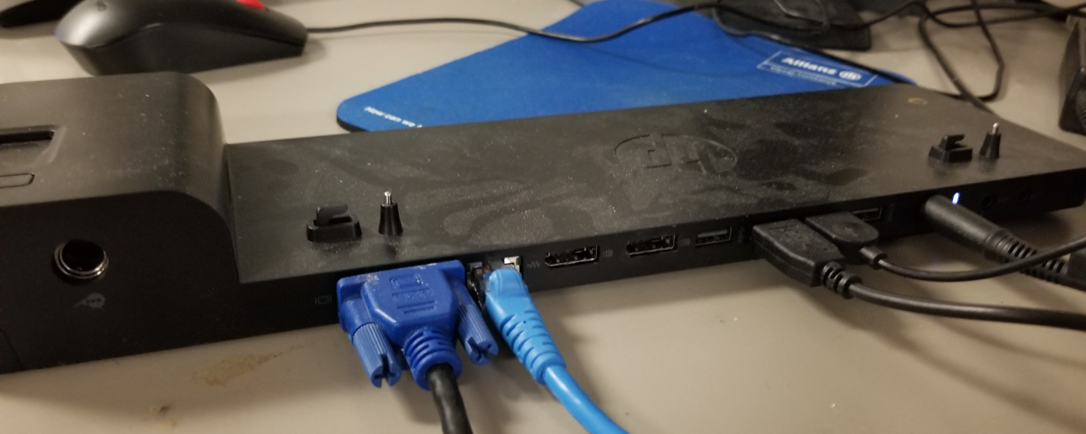

Log in to your laptop using the attached sheet showing your McAfee login and Windows login name.

If you have encountered any issue to this point, please have your supervisor create a ServiceNow ticket for your concern or call x55555 or Toll Free:1 833-492-0567

Be sure to include that you are working from home and it is your first login.

You should now find that you are at the main desktop view. You are not connected to the office network yet so you will find the home page will not work for example.

**Connecting to the Office**

To connect to the office network you use VPN software.

You need to enroll in the Veridium VPN system – please see other documentation for this important step.

**CONNECTING TO VPN**

Check Point VPN is used to remotely access Office networks and systems. The application is available on all Allianz Global Assistance managed laptops and computers

**PLEASE NOTE:**

To use a Check Point VPN Client connection you MUST be connected to your home Internet with the Ethernet cable. Please do not use an extender device in the electrical socket.

# How to connect to VPN

**Click the start button and search Checkpoint Endpoint security VPN and click on it ( one time step only)**

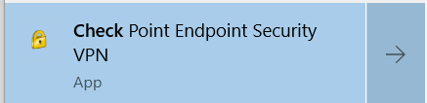

1. Now Open the Taskbar Notification Area (near the time and date section)

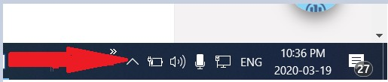

1. Right-click the Check Point lock icon and select Connec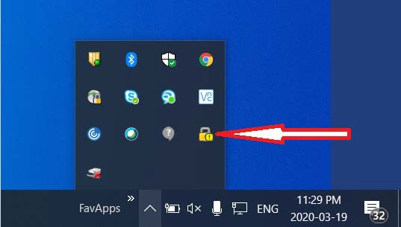t To…
2. Click Connect To…

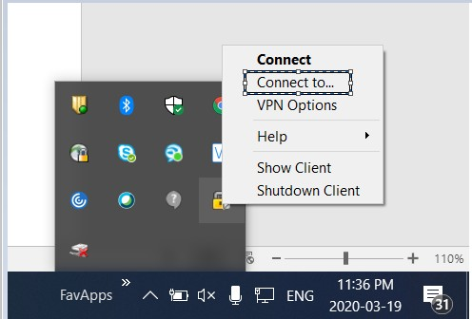

1. The logon window will appear for you to enter your credentials:

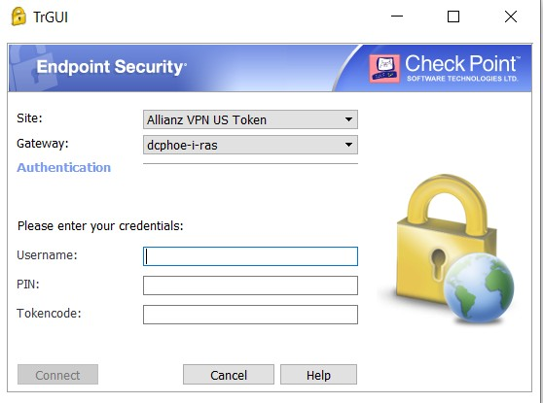

## USERNAME = YOUR FULL EMAIL ( For e.g. [joe.smith@allianz-assistance.ca](mailto:joe.smith@allianz-assistance.ca) )

PIN = 8 NUMBER PIN YOU HAVE CREATED DURING INITIAL VPN SETUP

TOKENCODE = TOTP CODE FROM YOUR VERIDIUM APP

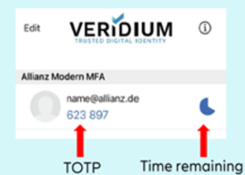

Click Connect button (Note- icon stays grayed out until username and password fields are populated)

The VPN software should indicate you have joined successfully. You can confirm by comparing as pictured below. If you are connected, you will see a filled in green dot on the lower right side of the lock icon.



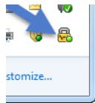

If you are having issues, try these simple troubleshooting tips:

* Make sure the computer is connected to your home Internet.
* Make sure you are typing your email address and PIN+passcode correctly
* You can test again on the same website that you made your PIN!

If you have any problem logging in to VPN, have your supervisor create a ServiceNow ticket for your concern.

**Important Notes:**

During the time between your first password change and the next time you restart your computer, some important synchronization occurs.

Please do not open any software applications at this time and proceed to change your Windows password.

Please do not restart the computer at this critical moment. And avoid restarting your computer at all for minimum one hour.

Please do not disconnect from the VPN for minimum one hour.

**Changing Your Windows Password**

Now that you have joined the office network, the next important task is to change your Windows password.

While remaining on VPN, do ctrl-alt-del on your keyboard. Choose ‘Change Password’

Change your password according with the password policy as follows (change it every 90 days):

Your new password must not contain your user name or part of your full name that exceeds two consecutive characters.

It must be at least twelve characters in length

In addition...

It must contain characters from three of the following four categories:

1. English uppercase characters (A through Z)

2. English lowercase characters (a through z)

3. Base 10 digits (0 through 9)

4. Non-alphabetic characters (for example, !, $, #, %)

If you have any problem logging in for the first time or difficulty changing your password, please have your supervisor create a ServiceNow ticket for your concern.

You may now log in with your new password and continue opening any applications you require.

# How to Disconnect from the VPN:

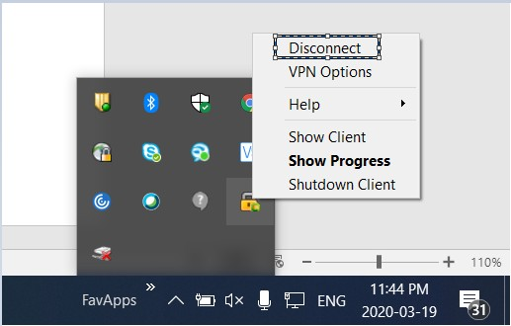

Please shut down your computer after each shift.